2/1/2023

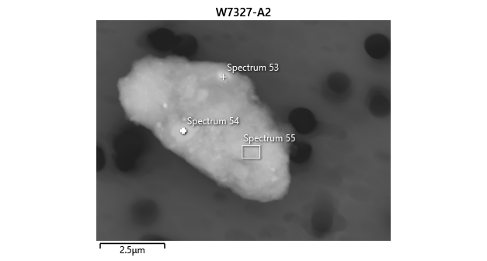

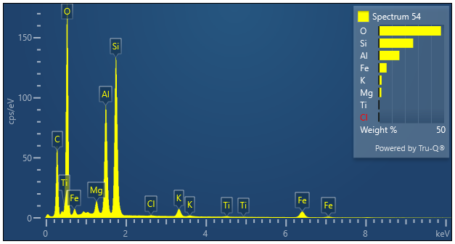

|  |  |  |
| --- | --- | --- |
| **Spectrum 54** |  |  |
| Element | Wt% | Wt% Sigma |
| O | 47.58 |  |
| Mg | 1.91 | 0.02 |
| Al | 15.77 | 0.04 |
| Si | 26.33 | 0.05 |
| Cl | 0.12 | 0.01 |
| K | 2.11 | 0.02 |
| Ti | 0.25 | 0.02 |
| Fe | 5.93 | 0.05 |
| Total: | 100.00 |  |