2/1/2023

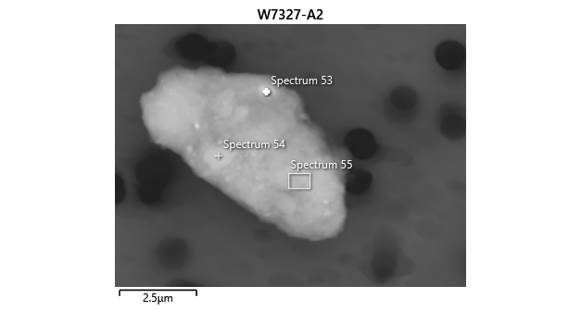

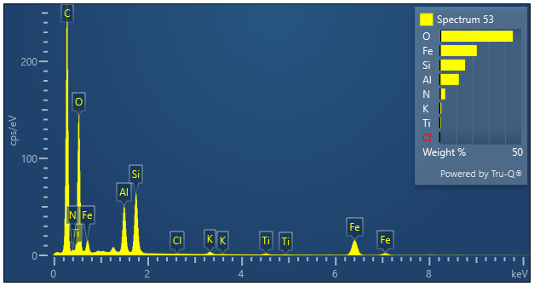

|  |  |  |
| --- | --- | --- |
| **Spectrum 53** |  |  |
| Element | Wt% | Wt% Sigma |
| N | 3.32 | 0.31 |
| O | 44.85 |  |
| Al | 11.70 | 0.12 |
| Si | 15.55 | 0.16 |
| Cl | 0.09 | 0.02 |
| K | 0.98 | 0.02 |
| Ti | 0.77 | 0.03 |
| Fe | 22.74 | 0.24 |
| Total: | 100.00 |  |