2/1/2023

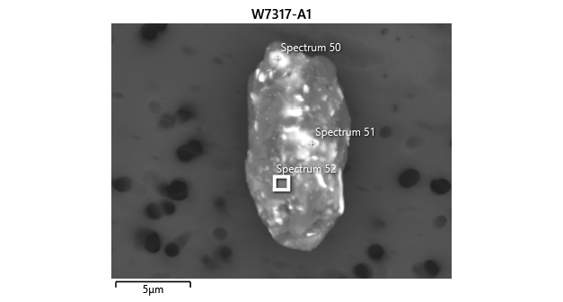

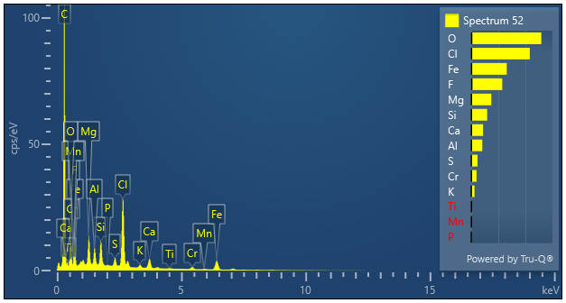

|  |  |  |
| --- | --- | --- |
| **Spectrum 52** |  |  |
| Element | Wt% | Wt% Sigma |
| O | 25.86 |  |
| F | 11.44 | 0.21 |
| Mg | 7.39 | 0.07 |
| Al | 4.07 | 0.06 |
| Si | 5.87 | 0.06 |
| P | 0.20 | 0.04 |
| S | 2.32 | 0.04 |
| Cl | 21.60 | 0.11 |
| K | 1.22 | 0.04 |
| Ca | 4.36 | 0.06 |
| Ti | 0.32 | 0.05 |
| Cr | 1.96 | 0.07 |
| Mn | 0.26 | 0.07 |
| Fe | 13.12 | 0.13 |
| Total: | 100.00 |  |