2/1/2023

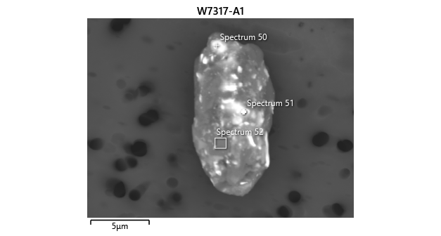

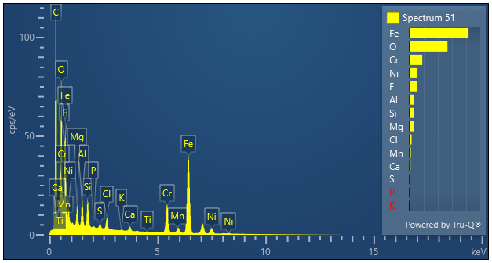

|  |  |  |
| --- | --- | --- |
| **Spectrum 51** |  |  |
| Element | Wt% | Wt% Sigma |
| O | 26.77 |  |
| F | 5.06 | 0.13 |
| Mg | 2.75 | 0.03 |
| Al | 2.95 | 0.03 |
| Si | 2.82 | 0.03 |
| P | 0.16 | 0.02 |
| S | 0.55 | 0.02 |
| Cl | 1.34 | 0.02 |
| K | 0.14 | 0.01 |
| Ca | 0.70 | 0.02 |
| Ti | 0.08 | 0.02 |
| Cr | 8.97 | 0.05 |
| Mn | 0.92 | 0.04 |
| Fe | 41.73 | 0.10 |
| Ni | 5.06 | 0.07 |
| Total: | 100.00 |  |