2/1/2023

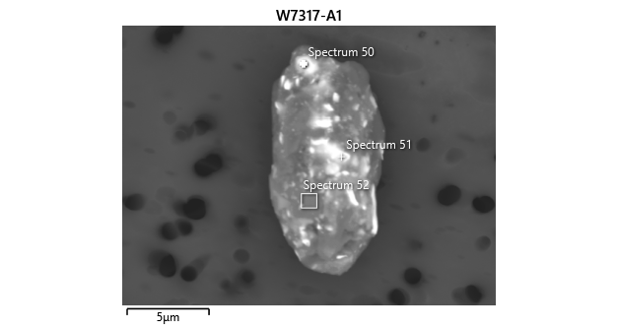

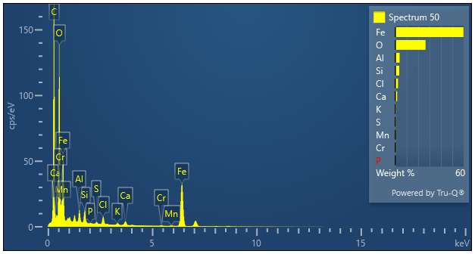

|  |  |  |
| --- | --- | --- |
| **Spectrum 50** |  |  |
| Element | Wt% | Wt% Sigma |
| O | 26.59 |  |
| Al | 3.79 | 0.04 |
| Si | 3.46 | 0.04 |
| P | 0.17 | 0.02 |
| S | 0.54 | 0.02 |
| Cl | 2.43 | 0.03 |
| K | 0.68 | 0.02 |
| Ca | 1.64 | 0.03 |
| Cr | 0.37 | 0.03 |
| Mn | 0.53 | 0.04 |
| Fe | 59.79 | 0.10 |
| Total: | 100.00 |  |