2/1/2023

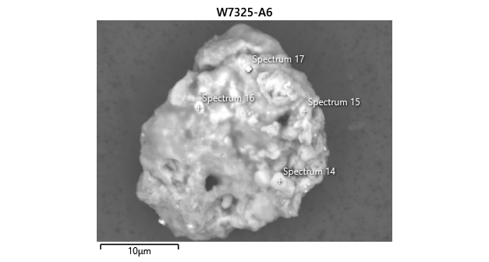

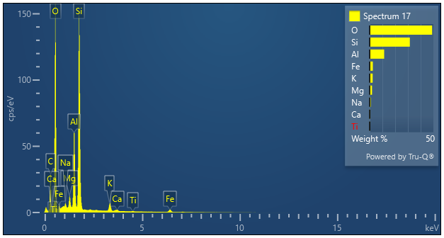

|  |  |  |
| --- | --- | --- |
| **Spectrum 17** |  |  |
| Element | Wt% | Wt% Sigma |
| O | 49.01 |  |
| Na | 0.78 | 0.02 |
| Mg | 1.86 | 0.02 |
| Al | 11.40 | 0.04 |
| Si | 31.52 | 0.06 |
| K | 2.35 | 0.02 |
| Ca | 0.41 | 0.02 |
| Ti | 0.16 | 0.02 |
| Fe | 2.50 | 0.04 |
| Total: | 100.00 |  |