2/1/2023

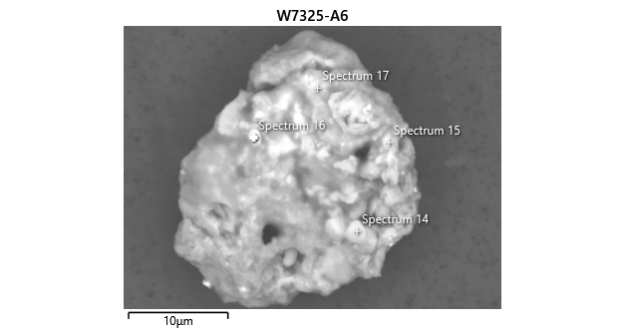

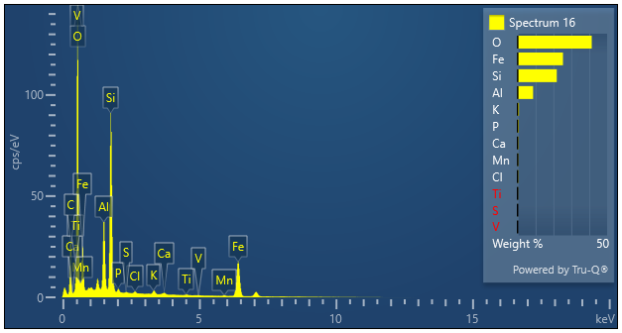

|  |  |  |
| --- | --- | --- |
| **Spectrum 16** |  |  |
| Element | Wt% | Wt% Sigma |
| O | 41.39 |  |
| Al | 8.63 | 0.04 |
| Si | 21.85 | 0.06 |
| P | 0.59 | 0.02 |
| S | 0.13 | 0.02 |
| Cl | 0.31 | 0.02 |
| K | 0.75 | 0.02 |
| Ca | 0.38 | 0.02 |
| Ti | 0.21 | 0.02 |
| V | 0.08 | 0.02 |
| Mn | 0.36 | 0.03 |
| Fe | 25.32 | 0.09 |
| Total: | 100.00 |  |