2/1/2023

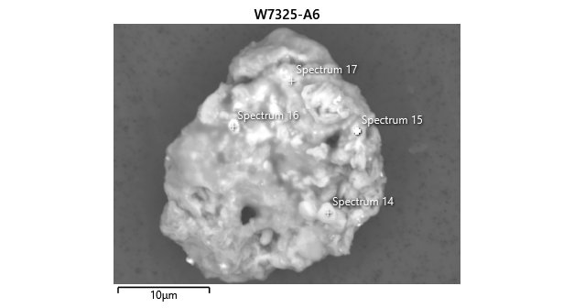

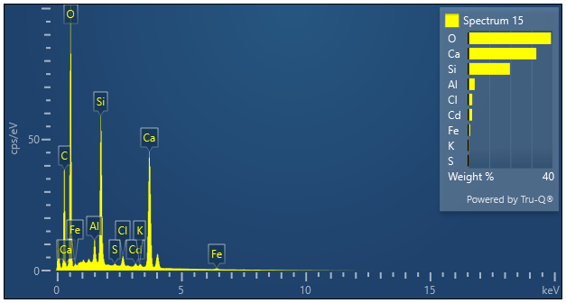

|  |  |  |
| --- | --- | --- |
| **Spectrum 15** |  |  |
| Element | Wt% | Wt% Sigma |
| O | 39.31 |  |
| Al | 3.10 | 0.04 |
| Si | 19.78 | 0.06 |
| S | 0.31 | 0.02 |
| Cl | 1.91 | 0.03 |
| K | 0.44 | 0.03 |
| Ca | 32.35 | 0.08 |
| Fe | 0.96 | 0.06 |
| Cd | 1.83 | 0.07 |
| Total: | 100.00 |  |