2/1/2023

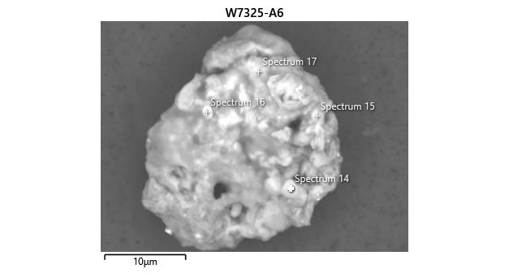

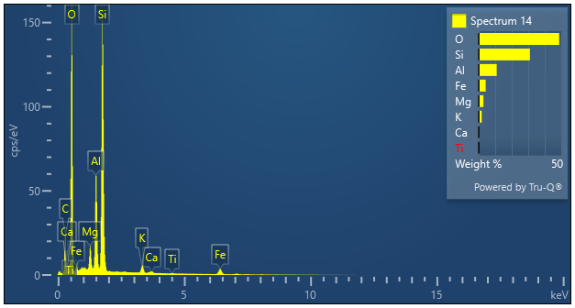

|  |  |  |
| --- | --- | --- |
| **Spectrum 14** |  |  |
| Element | Wt% | Wt% Sigma |
| O | 48.73 |  |
| Mg | 2.81 | 0.02 |
| Al | 10.89 | 0.04 |
| Si | 31.04 | 0.05 |
| K | 1.75 | 0.02 |
| Ca | 0.39 | 0.02 |
| Ti | 0.17 | 0.02 |
| Fe | 4.21 | 0.05 |
| Total: | 100.00 |  |