2/1/2023

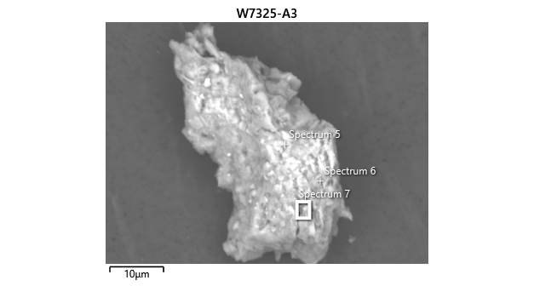

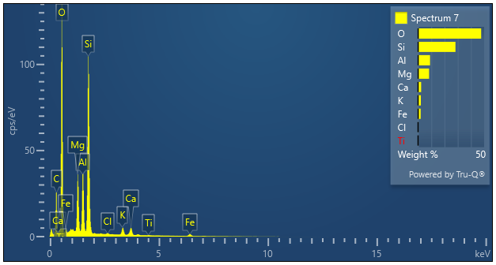

|  |  |  |
| --- | --- | --- |
| **Spectrum 7** |  |  |
| Element | Wt% | Wt% Sigma |
| O | 47.72 |  |
| Mg | 8.31 | 0.04 |
| Al | 9.05 | 0.04 |
| Si | 28.31 | 0.06 |
| Cl | 0.24 | 0.02 |
| K | 2.07 | 0.03 |
| Ca | 2.28 | 0.03 |
| Ti | 0.11 | 0.02 |
| Fe | 1.91 | 0.04 |
| Total: | 100.00 |  |